Lab 3

**For Q1 and Q2 you should use structural design.**

1. Flip flops (using gate level structural design)

a. Design a D Latch

b. Using the D Latch, design a D Flip Flop

c. Design a T Flip Flop

d. Design a JK Flip Flop

You can assume the appropriate inputs necessary.

1. 8 bit register/shift register (structural design)

a. Design 8 bit register with reset input by using flip flop blocks you designed previously.

b. Design 8 bit shift register. ( Data will come from LSB and will be shifted through MSB )

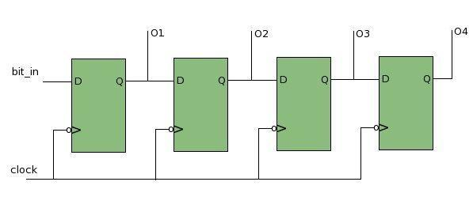

Shift Register(Neglect Reset Input)

1. PWM: Pulse width modulation is a popular technique used to control the effective voltage at a source by modifying the duty cycle of the input voltage(the percentage of time in which the voltage is high).

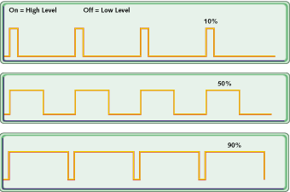

PWM Example with 10%, 50% and 90% duty cycles

In this problem, you will emulate a PWM generator. The inputs to the module are a clock signal (Clk)and two select lines (s). Your module must meet the following specification:

If s = 00, the output must stay high for 1 clock cycle and go low for the next three clock cycles.

If s = 01, the output must stay high for 2 clock cycles and go low for the next 2 clock cycles.

If s = 10, the output must stay high for 3 clock cycles and go low for the next clock cycle.

If s = 11, the output must stay always high.

To do this, first create a 2 bit counter and then generate the PWM output using the outputs of the counter.

1. Divisibility by 3 checker!

Construct an FSM that checks if a binary number is divisible by 3. Specifically, your FSM should take the bits sequentially starting from the LSB and output REM = 1 if the number is not divisible and REM = 0 if it is divisible. [Hint: You can do this using an FSM that has 6 states. Use the fact that 2^(odd number) = 2 MOD(3) and 2^(even number) = 1 MOD(3)].

BONUS: FSMs with lesser than 6 states will get a bonus point of +1

1. Design a traffic light logic

Broadway St. is a very busy street on the other hand Elm St. is not busy at all and they are both one direction. As long as there is no car on Elm st. TL2 will be always red and TL1 will be green. If TL2 was red for more than past 40 clock cycle when a car coming from Elm. St. stops at the intersection TL1 will turn red TL2 will turn green for 10 clock cycle then it will turn red again. TL1 and TL2 have 3 outputs, RED,GREEN and YELLOW and there is a SENSOR input that can detect if there is a car on Elm St. or not.

When traffic lights are changing state:

1)first turn yellow from green(wait for 3 cycle on yellow)

2) then turn red and other TL turn green from red.

